BA820 – Project M4

Cover Page
- Project Title:Survival Strategies, Attrition Patterns, and Audience Engagement in the Alone TV Series
- Section and Team Number: A1 – Team 08
- Student Name:Yanlun Li

1. Refined Problem Statement & Focus (~0.5 page)
The core domain question investigated in this project remains unchanged from M2: Do participants’ loadout configurations give rise to distinct survival strategy types, and are these strategy types systematically associated with survival outcomes?
In earlier milestones, the emphasis was primarily on discovering whether meaningful clusters could be identified in loadout space using Jaccard similarity and hierarchical clustering. The underlying assumption was that if discrete strategy types exist, they should be recoverable as stable clusters and exhibit some alignment with survival duration or exit mechanisms.
In this milestone, the framing shifts from discovery to validation. Rather than asking whether clusters can be produced, the focus is now on whether the observed structure is robust to methodological choices and representation assumptions. Specifically, I evaluate (1) clustering stability under bootstrap resampling, and (2) sensitivity of cluster assignments to alternative similarity representations, including frequency-weighted features.
This refinement challenges the implicit assumption that any identified cluster structure reflects intrinsic, representation-invariant strategic regimes. The analysis shows that while the Jaccard-based clustering is highly stable under resampling, cluster assignments change substantially when item weighting is introduced. This indicates that the apparent structure depends on how similarity is defined.
At the same time, the assumption that stable clusters should correspond to meaningful outcome differentiation is partially invalidated. Exit mechanisms and survival duration do not align strongly with either the baseline or weighted clustering solutions, suggesting that loadout variation operates within a constrained preparation space rather than forming sharply distinct strategic archetypes.
Overall, the problem focus has evolved from identifying clusters to evaluating the structural defensibility and substantive interpretability of those clusters.

2. EDA & Preprocessing: Updates (~0.5 page)
The EDA and preprocessing pipeline remains unchanged from earlier milestones. Loadouts were encoded as binary item vectors using multi-label binarization, forming a participant-by-item matrix suitable for set-based similarity analysis. Jaccard distance was selected as the baseline metric to reflect overlap in selected items while ignoring shared absences. Clustering was conducted in a fully unsupervised manner, with survival duration and exit type excluded from feature construction. No additional data cleaning or transformation was required beyond consistent encoding and categorical handling of exit outcomes.
In M4, no new EDA or preprocessing steps were introduced. The refinement focuses on validating structural robustness rather than altering the underlying data. The only adjustment was constructing a frequency-weighted version of the same binary matrix to test representation sensitivity; this modifies feature contribution but does not change the dataset itself. Thus, all refinements build directly on the original preprocessing framework established in M2.

3. Analysis & Experiments (~2 pages)

3.1 Bootstrap Stability and Parameter Exploration
In M2, hierarchical clustering with Jaccard distance suggested coarse strategy groupings in loadout space. However, visual coherence alone does not establish structural validity. In M4, I introduced a bootstrap-based stability analysis to test whether cluster assignments persist under sampling variation.
Participants were resampled with replacement, clustering was recomputed across different values of k (3–5) and linkage methods (average and complete), and assignments were compared to the baseline using Adjusted Rand Index (ARI). The Jaccard + average linkage solution with k = 3 showed consistently high ARI across bootstrap runs, indicating strong stability. Increasing k reduced consistency, and complete linkage produced weaker reproducibility.
This analysis validates that a coarse three-cluster structure is defensible under sampling variability, while finer partitions are not. It challenges the earlier implicit assumption that additional clusters necessarily capture meaningful segmentation. The strategy space appears low-dimensional and only supports stable coarse grouping.

3.2 Method Upgrade: Frequency-Weighted Representation
To test representation robustness, I constructed a frequency-weighted version of the binary loadout matrix, upweighting rare items and downweighting common ones. Hierarchical clustering was then repeated using cosine distance.
The weighted clustering solution differed substantially from the baseline (ARI ≈ 0), indicating strong sensitivity to representation choice. Under Jaccard similarity, clusters are driven by shared baseline items; when rare items are emphasized, partitions reorganize entirely.
This finding is central. It suggests that the apparent cluster structure reflects geometry induced by shared necessities rather than representation-invariant strategic archetypes. While the Jaccard-based partition is stable under resampling, it is not invariant to feature weighting. The loadout space contains a dominant consensus manifold with peripheral variation rather than sharply defined regimes.

3.3 Cluster × Exit Type Alignment
To evaluate substantive relevance, I examined whether stable clusters correspond to different exit mechanisms. Cross-tabulation shows that Clusters 1 and 2 have nearly identical exit distributions, while a smaller third cluster is more homogeneous but limited in size. No cluster cleanly maps to a distinct exit pathway.
This suggests that stable clustering does not translate into strong outcome differentiation. The assumption that identifiable strategy types should correspond to distinct failure modes is therefore weakened. Structural reproducibility does not imply explanatory power.

3.4 Exit-Conditioned Similarity
To move beyond cluster-level summaries, I analyzed pairwise Jaccard similarity. If exit mechanisms structure loadout space, participants with the same exit type should exhibit higher similarity.
The observed difference in mean similarity between same-exit and different-exit pairs (Δ ≈ 0.007) is minimal, and distributions largely overlap. Exit pathways do not form tight geometric neighborhoods in loadout space. This reinforces the interpretation that preparation differences exist within a shared baseline configuration rather than defining distinct strategic regimes.
Technically, this step required careful construction of pairwise comparisons to avoid duplication. Conceptually, it confirms that outcome alignment is weak even when examining fine-grained similarity rather than cluster labels.

3.5 Methodological Reflections
Several alternatives were explored but not retained. Increasing k reduced stability and was abandoned. Complete linkage did not improve robustness. More complex probabilistic models were considered conceptually but excluded to maintain interpretability and course alignment.
A key technical distinction emerged between sampling robustness and representation robustness. Bootstrap analysis confirms stability within a fixed similarity definition, whereas weighting reveals geometric sensitivity. Together, these analyses provide a more nuanced understanding of structure than M2.

3.6 Summary of What Worked and What Did Not
The refined analysis shows:A reproducible three-cluster structure under Jaccard similarity.Weak alignment between clusters and exit mechanisms.Minimal pairwise similarity differences by exit type.Strong sensitivity of clustering to representation weighting.
These results indicate that loadout variation exhibits stable low-dimensional structure under shared-necessity similarity but lacks representation-invariant discrete strategic regimes. Strategy differentiation appears constrained and continuous rather than segmented into sharply distinct archetypes.

4. Findings & Interpretations (~1 page)
The analysis reveals a consistent but nuanced picture of strategy differentiation in loadout space.
First, a coarse three-cluster structure is reproducible under resampling. This indicates that participants’ item selections are not random; there is a stable baseline geometry in how contestants configure their preparation. In practical terms, survival strategies do not scatter arbitrarily across the item space. Instead, they concentrate around a limited number of broad preparation profiles.
However, this structural stability does not translate into strong outcome segmentation. Clusters do not meaningfully differentiate exit mechanisms, and survival duration distributions largely overlap across groups. Even when examining pairwise similarity directly, participants who exit for the same reason are only marginally more similar than those who exit differently. The magnitude of this difference is small and visually indistinguishable in distribution plots.
Together, these results challenge a key assumption: that distinct preparation types should correspond to distinct survival outcomes. The evidence suggests otherwise. While contestants cluster around shared preparation patterns, these patterns do not strongly determine how they exit the competition. Preparation appears to operate within a constrained baseline space rather than defining sharply separated strategic regimes.
The representation sensitivity analysis deepens this interpretation. When rare items are upweighted, the cluster structure reorganizes substantially. This indicates that the apparent segmentation depends on how similarity is defined. Under shared-necessity similarity (Jaccard), structure is stable; under rare-item emphasis, partitions shift. This suggests that what appears as discrete clusters may reflect dominant common configurations rather than intrinsic, representation-invariant strategy types.
Conceptually, the loadout space resembles a compressed manifold rather than a landscape of sharply separated categories. Most contestants share a core set of essential items, and variation occurs at the margins. These marginal differences are insufficient to generate strong, outcome-aligned segmentation.
From a domain perspective, this has meaningful implications. If preparation strategies do not strongly determine exit pathways, then survival outcomes are likely driven more by in-season factors—environmental variability, resource conditions, physical resilience, and adaptive decision-making—than by ex-ante configuration alone. In other words, initial loadout choices set a baseline but do not rigidly define competitive trajectories.
For decision-makers or designers analyzing competitive formats, this suggests that structural diversity in preparation may be more limited than intuitively assumed. Apparent strategic diversity may mask a shared core necessity structure. Distinguishing success may depend less on categorical strategy choice and more on execution under uncertainty.
Overall, the refined analysis shifts the conclusion from “identifying strategy types” to understanding the limits of strategic segmentation. There is stable structure, but it reflects constrained variation rather than sharply distinct archetypes. Preparation matters—but within boundaries that narrow the range of viable differentiation.

Appendix
Shared GitHub Repository (Required)
- Github Link
Folder M4-YanlunLi contain my M4 works
Supplemental Material (Highly Recommended)

Stability Analysis
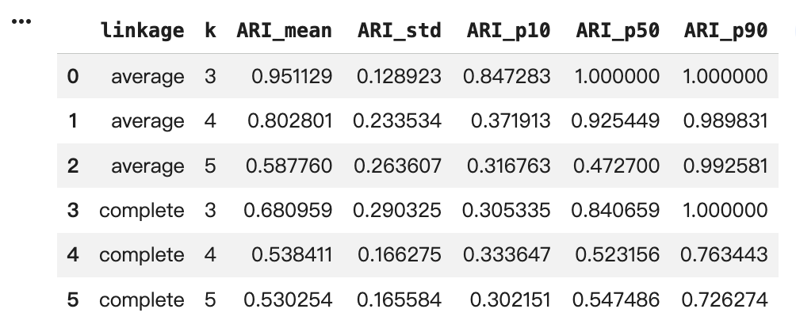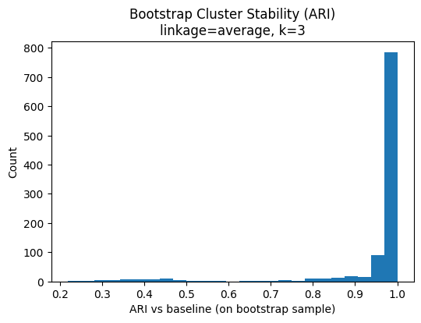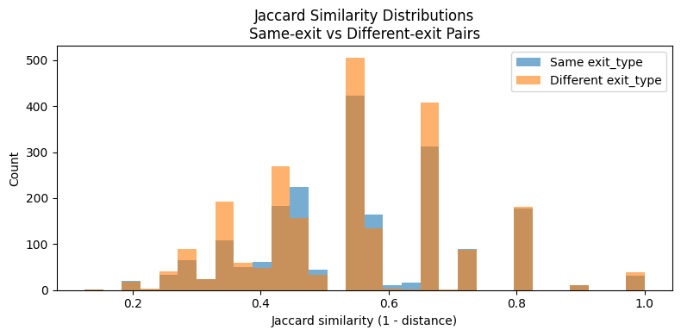
Process Overview
The analysis begins by consolidating participant loadouts into a binary item matrix, enabling set-based similarity comparisons. Jaccard distance and hierarchical clustering are used to identify baseline strategy groupings(M2). In M4, the focus shifts to structural validation: bootstrap resampling evaluates clustering stability across parameter choices, and a frequency-weighted representation tests sensitivity to similarity definitions. Cluster assignments are then compared descriptively to survival duration and exit mechanisms, and pairwise similarity analysis assesses whether outcome groups form tighter geometric regions in loadout space. The pipeline progresses from data structuring to structural robustness testing and finally to interpretive synthesis, emphasizing validation over model expansion.
Use of Generative AI Tools
ChatGpt Link

